BUSSTEPP 2026
Lunch Options

West Hub café
Café bar, canteen and coffee shop
~20 minute walk – exit the front of the site (Wilberforce Road) and follow the main road to the West Cambridge site or the footpath along the back and use the 3rd entrance onto the West Cambridge site

Cambridge City Centre
Various places for a meal, takeaway food, sandwich or a coffee
20 minute walk either via the main road and turn left at the crossroads into town, via the Playing Fields or via the University Library and follow the footpath and across the river.

Churchill College/Fitzwilliam College
Canteen
6/9 minute walk – exit the site via Reception, through the gates and turn right to the main road. Cross the road and Churchill is on the left and Fitzwilliam is just further up the road.

Centre for Mathematical Sciences (on site – across the bridge from MR9)
Café – hot and cold food, sandwiches, drinks, cakes

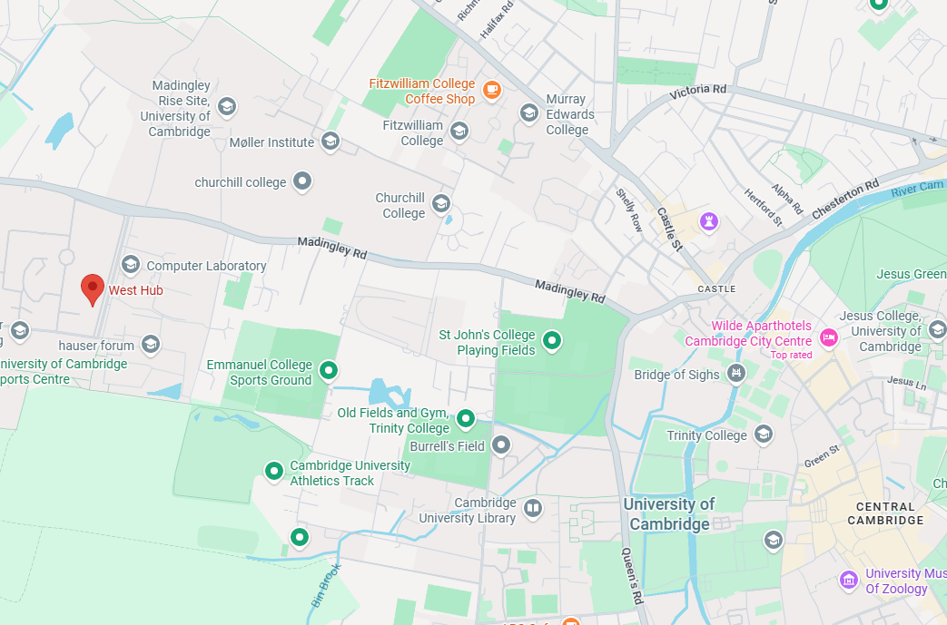
CMS

